**Exercise # 9**

**Question # 1**

Sparse Matrices are very useful in the field of artificial intelligence, parallel processing and many other fields of computer science. Sparse matrices are the matrices which have zero values usually. Your task is to write a C-program which computes the percentage of sparsity in 2D- matrices provided by the user. Dimensions of the matrix would also provided by user. The formula for counting percentage of sparsity is mentioned below: number of zero elements.

In a similar way density of the matrix can be determined by number of non-zero elements in matrix, you need determine the density also.

**Question # 2**

Write a C-program which computes the transpose of a matrix provided by user, but in addition to that you don’t need to create another matrix and there should be no extra variable used. Furthermore, number of rows and columns must be asked from user.

**Question # 3 & 4**

Write a C-program which fills the two matrices randomly having the values between floating point range of 0 and 1 in addition to this select at least 70% of the elements in both of the matrices randomly and make their values zeros. At the end you need to perform multiplication of the matrices (You need to wrote a code for performing multiplication)**.**

* **Perform multiplication of the matrices without having zeros values.**
* **Perform multiplication of the matrices having zero values.**
* **Keep dimensions of the matrices at least 10000X10000 (initially choose little sizes to write code).**
* **At the end compute the time of the multiplication in both cases and report the time.**
* **Comment about the timing of both of multiplications.**

|  |  |
| --- | --- |
| **Random number generator between float range of 0 and 1** | **Random number generations for locations** |
| #include <stdio.h>  #include <stdlib.h>    void main()  {  float n;  int ch;    printf("\nRandom numbers between 0 to 1");  do  {  n = (float)rand()/RAND_MAX;  printf("\nRandom number: %f", n);  printf("\nDo you want to generate again (1/0): ");  scanf("%d", &ch);  } while(ch == 1);    } | #include <stdio.h>  #include <time.h>  #include <stdlib.h>    /* The division of integers usually gives a  * result smaller than max */  int randomRange(int min, int max)  {  return ( rand() % ( max - min ) ) + min;  }    int main(void)  {  int i=0;  srand(time(NULL));  while(i++!=10)  printf("%d\n", randomRange(0,1000));  return 0;  } |

**Question # 5**

Write a C-program for a Simple calculator, having functions addition, multiplication, division, subtraction, power and the user should be asked to input the choice and after that user must enter the arguments for the function.

**Question** # 6

In the field of deep learning, the famous activation functions are ReLU and Sigmoid. You need to write a C-Program which can calculate the activation values of the provided inputs. The formulae for ReLU and Sigmoid are mentioned below.

Note: For Sigmoid you may use math.h library functions.

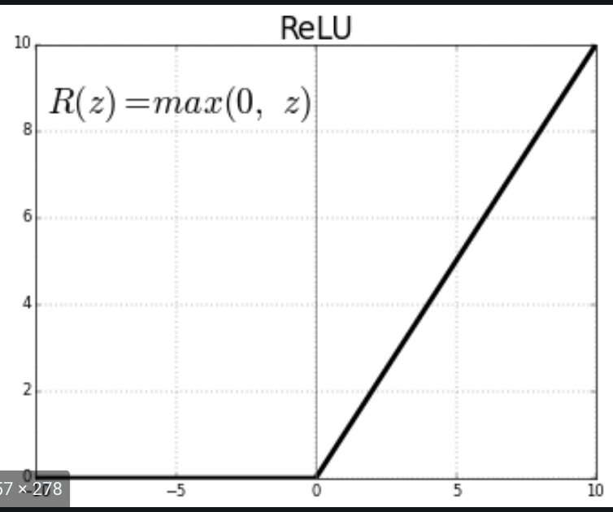 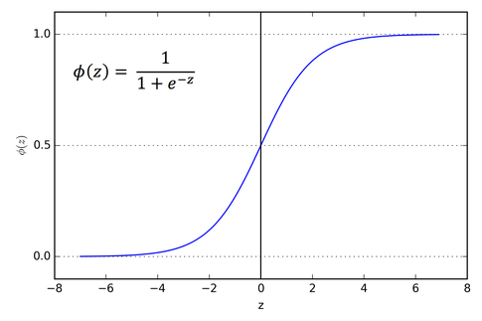

**Question # 7& 8 9.**

**Arrays, String and Functions**

**I would grade the question relatively and the one who makes this perfect with need and clean coding would get full marks.**

Alice and Bod want to communicate using internet and they want to make sure that their privacy is maintained. They contact Jack, who is a cyber security specialist and Jack suggested them to go for RSA algorithm to encrypt and decrypt messages. Furthermore, Jack taught them the functionality of RSA.

At first RSA encodes the strings.

If the string is HELLO

**Write separate functions for encoding the strings and decoding the integer numerals.**

|  |  |  |  |  |
| --- | --- | --- | --- | --- |
| H | E | L | L | O |
| 07 | 04 | 11 | 11 | 14 |

* Here p and q are primes which are selected randomly( you need to create a function which generates the random numbers and verifies whether a generated number is prime or not). Then come up with p and q. (p and q must be different).

K = (p-1)*(q-1). n = p*q.

* Randomly generate an e, such that 1<e <K and gcd(e, K)=1 i.e and e and N must be co prime (relatively prime).
  + You need to implement this logic using functions(Include GCD Calculation also).
* At last randomly choose d such that e*d mod K = 1. You need to implement this using functions also.
* Finally create two functions for encryption and decryption.

Equation for encryption is

Equation for decryption is

**User should be asked to perform encryption and decryption at the start**

**Example**

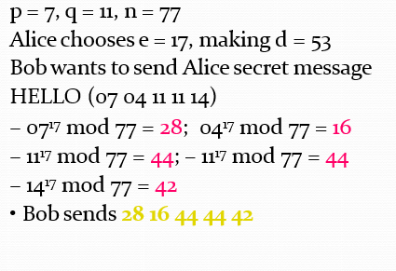

**Question # 10**

Your solutions must have proper indentation, comments, and should be neat and clean. Furthermore, cheating is highly discouraged and would lead to disciplinary action against you.

